Tetris Inventory System how-to document.
Alessandro van de Nadort 230803
Contents
Introduction 1
Project Setup 3
Gym & Demo Showcase 4
Quick Setup 5
Inventory setup and settings 6
Creating and editing items 10
Common UI Setup 16
Blueprint Deep-dive 17
Other 20

Introduction
Welcome to the how-to document for the Tetris Inventory System. This system is intended for beginner / intermediate level Unreal developers and designers to easily setup a Resident evil 4-like inventory system.
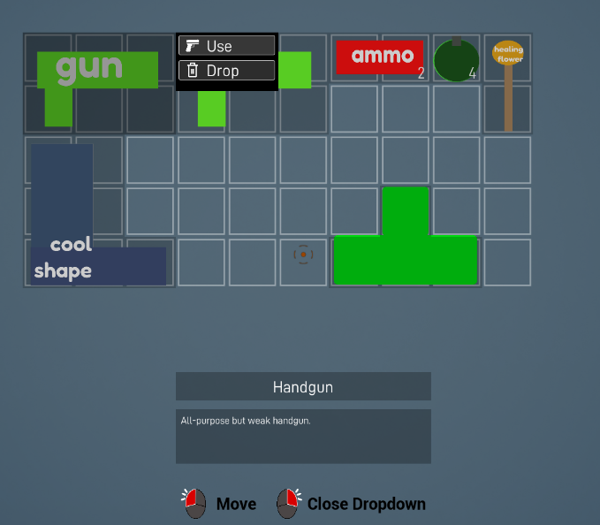
This project provides
- An easy-to-use and customize template for making a Tetris inventory system.
- A quick item creation and editing system with support for custom-shaped items.
- Built-in common-UI to support expansion and other widgets in your game.
- Support for unreal 5.4.1
This project does not provide
- A crafting system.
- Non-rectangular inventory grids.
- Advanced dropdown menu logic

In-game control scheme:
Blueprint comments colour coding

Project Setup
- Open the project in version (5.4.1) of unreal or higher.
- Right-click the TetrisInventorySystem folder and hit migrate:
- Unreal automatically selects the files that need to be migrated for you, press OK.
- Navigate to your own project files and select that project's Content folder to start the migration of the tool. You should now have access to the tool in your own project.

Gym & Demo Showcase

Gym content
The gym level is there to showcase the functionality of the system in-engine and provides some annotations.
- The gym level is in Content / TetrisInventorySystem / Gym/ Maps

Demo content
The demo level showcases possible gameplay scenarios the player could find themselves in. You can find the demo level in: Content / TetrisInventorySystem / Demo / L_Demolevel
- Room 1
  - Room 1 makes the player fit 3 keys and some essential items into their inventory.
  - The keys are laid out in a way that they are picked up in a certain order so the player has to rearrange their inventory to fit the third one.
  - By rearranging they interact with moving and rotating to fit the puzzle.
- Room 2
  - In room 2 the player is confronted with a hypothetical scenario for which they need to prepare their inventory.
  - Critical decision-making gameplay on what items to bring and which to leave is shown using different items and sizes all with their own description.

Quick Setup

Inventory setup and settings

Inventory Setup
This part describes how to create and add the inventory component to your player and change all sorts of gameplay and aesthetic changes within.

Step 1: Add inventory to player
- Open the player character blueprint you want an inventory for.
- Locate the component tab and press ‘+ Add’ to add the 'AC_Inventory' component.
- 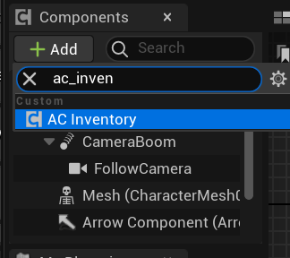
- All inventory functionality and input is now attached to your player. Test it by playing your level and pressing TAB to open it up!

Inventory settings
Select the inventory component and view the inventory settings in the detail panel.
Open the dropdowns to get acces to, and customize all the inventory settings you need.
Here is a list of the core gameplay settings (General, Size and Rotation) with some more information.

- General
  - Inventory Enabled
    - When false, disables the ability to open / close the inventory.
    - Setting gets referenced in these blueprints:
      - AC_Inventory

  - Should Pause
    - When true, pauses the game when the inventory is open.
    - Setting gets referenced in these blueprints:
      - AC_Inventory

  - Show Item Description
    - When false, remove the item description widget from the inventory
    - True:
    - 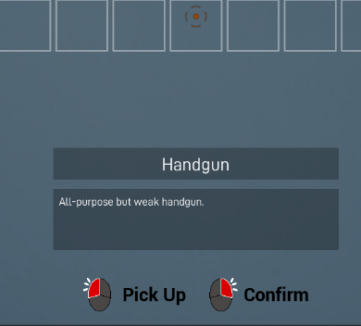
    - False:
    - Setting gets referenced in these blueprints:
      - WBP_Inventory

  - Show Controls
    - When false, remove the input widget from the inventory
    - True
    - 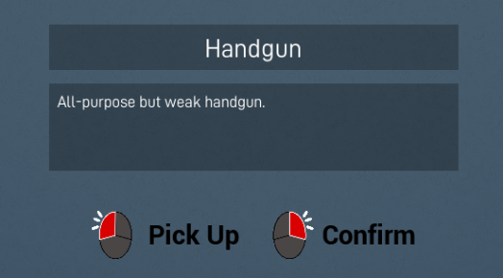
    - False:
    - Setting gets referenced in these blueprints:
      - WBP_Inventory

  - Dropdown Enabled
    - When false, disabled the dropdown menu from being opened.
    - It also removed the dropdown control from the input widget.
    - Setting gets referenced in these blueprints:
      - WBP_Item
      - WBP_InputIcons
- Size
  - Inventory Size
    - How many total slots this inventory has.
    - Setting gets referenced in these blueprints:
      - AC_Inventory
      - WBP_Inventory
      - WBP_Grid

  - Inventory Width
    - The maximum horizontal width of the inventory slots.
    - 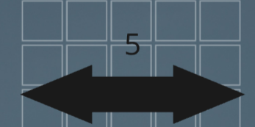
    - Setting gets referenced in these blueprints:
      - AC_Inventory
      - WBP_Inventory

  - Slot Size
    - The individual size of each slot in pixels. Also affects items.
    - 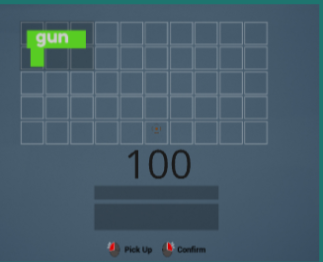
    - Setting gets referenced in these blueprints:
      - WBP_Grid

- Rotation
  - Item Rotation Mode
    - How does the item rotate in the grid?
    - No rotation: items cannot be rotated in the inventory.
    - Full 360 rotation: every time you rotate an item, it does so by 90 degrees.
    - Straight and sideways rotation: item can only be rotated in its normal position and 90 degrees sideways (Like Resident Evil)

Different inventories with different settings?
If you want more than 1 inventory type in your game (inventory type as in, different inventory sizes, assets functionality etc) , make a child of AC_Inventory and use that component instead of the default AC_Inventory.
- File path for AC_Inventory: Content/TetrisInventorySystem/Blueprints

Creating and editing items
This section will explain how you can easily create your own items and set all their attributes.

Adding a new item:

Step 1: Create data asset
Each item is stored as a data asset which contains all the item's information like Name, Texture and Size.
Navigate to Content / TetrisInventorySystem / Items
- Select DA_Template and duplicate the asset.
  - You can alternatively create one yourself. Make sure pick the DA_Items class for ‘Data asset instance’
  - 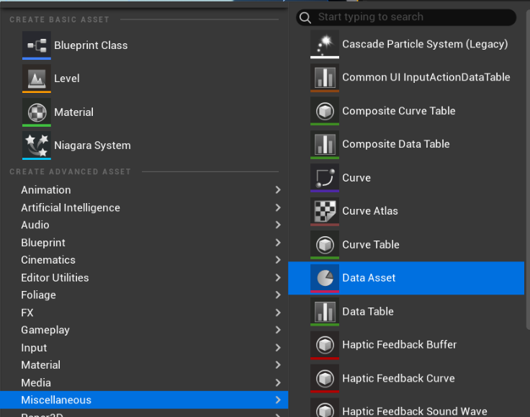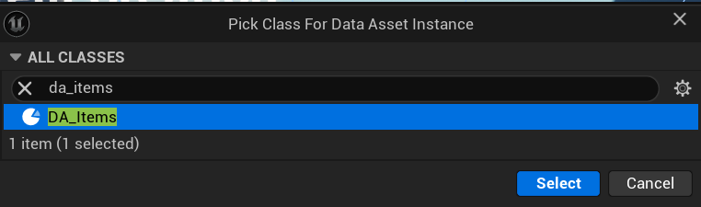
- Give the new item a unique, relevant name (E.g. DA_Handgun. DA_Fish1)
- You are now ready to edit the item’s attributes directly (scroll down) or import an item texture first.

Step 2: Import item texture
- Import the texture for your item into your own texture folder or use the Content / TetrisInventorySystem / Items / Textures folder to keep everything tidy!
What resolution should the image be?
- Depends on how many slots the item takes up in the inventory.
- Locate the setting ‘SlotSize’ in the inventory component. This value is the amount of pixels by pixels 1 slot is.
- E.g. if you are making an item that is 2 x 1 slots and your slot size is 100; the resolution of the item image should atleast be 200x100 px, and the aspect ratio 2:1.
Image padding?
- To make coloured background feedback work at its full effect you need to leave some space between the image and the image border.
- E.g. if your slot size is 100; 10-20 pixels margin will make the item look better.

Step 2: Set texture settings
- When you have imported your texture, open it up and set these values in your detail panel:
  - Texture group to UI
  - Compression settings to UserInterface2D
Imported many textures?
- You can edit these settings of multiple imported textures all at once.
- Select all textures, right click them, navigate for Asset actions>edit selection in property matrix
- A window opens in which you can change these settings for all selected textures at once.

Editing an item’s attributes
- Open the data asset to access that item’s attributes.
- 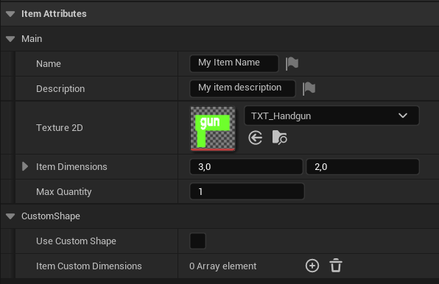
Each attribute explained:
Attribute: | Description:
Name | The name of the item that will display when you hover over it in the inventory
Description | The description of the item that will display when you hover over it in the inventory
Texture 2D | The texture (from ‘Adding a new item’) that your item will display in the inventory.
Item dimensions | The rectangular size of the item in your inventory.  - First value is width  - Second value is height  - Make sure these are rounded values
Max Quantity | Stacking size of the item: how many you can carry of the same item in the same slots that 1 item occupies.
Use Custom Shape | Set to true when you want to create an item that is not rectangular. This will override the Item Dimensions attribute with the value below:
Item custom dimensions | - This is an array of coordinates on a local grid for the item. This allows you to make shapes other than rectangles.  - Each array element is a coordinate that starts at 0,0.  - For example, if you want to make an L-shaped object you can input the coordinates in blue:

Testing item / placing item in world
- Go to Content/TetrisInventorySystem/Blueprints and drag BP_Item into your level.
  - BP_Item is a blueprint in which you can set an item and place in the world.
  - When a player with an AC_Inventory component overlaps it, it will try to add that item to the inventory.
  - If it succeeds, it disappears. If not, it will stay with the remaining quantity of items it failed to add.
- Select it in the level and change the Item Structure variable to whatever item you want.

If you want to modify the attributes an item can have, read ‘Modify item attributes’

Modify item attributes (advanced)

Step1 : Open DA_Items
- DA_Items is where all shared functionality of items is stored, like their attributes
- Locate DA_Items in the folder Content/TetrisInventorySystem/Blueprints
  - Or by searching for it In the content browser search bar.

Step 2: Modify attributes
- When you open DA_Items you can find the variable panel in the bottom left.
- 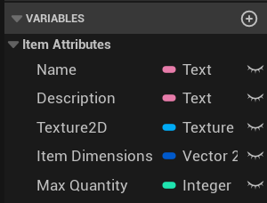
- Click on the (+) to add a new attribute or edit / remove variables by clicking on already existing ones.

Step 3: Getting attributes in blueprints
- Each item is saved in the inventory (variable) with an Item position and stores the Item Slot Data.
- Item Slot Data contains the data asset with all attributes. Get a reference to the slot data, break it open and access your data through that.
- 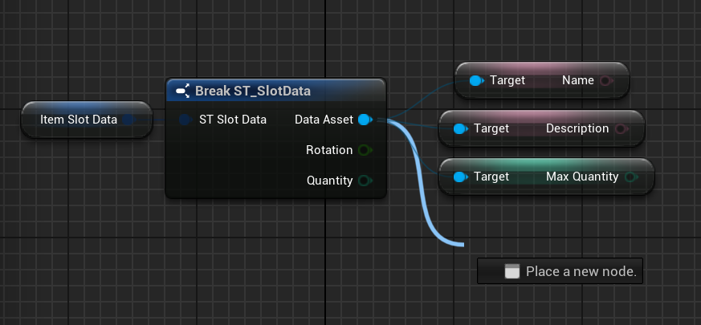

Common UI Setup
This project uses Common UI for:
- Changing the input icons when a gamepad is detected
- Common Text Styles to replace text settings.
To get access to the project's integration of Common UI, follow these steps:
- Install the Common-UI plugin and restart the engine.
- Open project settings, search for the settings and set them to what's down below:
- Further information about Common UI and how to work with it can be found on the official unreal website. This is not needed to get the project to work but can be useful for advanced customization.

Blueprint Deep-dive

AC_Inventory
- Pink comment colour in a blueprint means that this section is setting a value from a setting in the inventory.
- If you want to override this value manually in the blueprint and do not wish to use the inventory setting; delete the code in the pink comment and re-connect the execute pins.

Widget Nesting

WBP_Inventory
WBP_Inventory is the widget on which the Grid, description and input get displayed. It passes events like add, remove and drop item from the grid to the AC_Inventory.
- You can easily use the UE widget system to rearrange all the parts in the inventory to make it fit into a widget you already created.
- For it to remain functional with the component though, make sure to pass this data and set the event dispatchers:
- You can also wrap the wbp_grid in the inventory in a scroll box, giving you a escape from tarkov-like inventory.

WBP_Grid
WBP_Grid is the actual grid that appears on the player screen. It has all functionality for moving rotating items etc.
- Useful variables that can be accessed in the grid:
  - Moving item: the item widget that is currently being moved
  - CurrentLocation: the current position of the item being moved
  - MappedGridSlots: all slot widgets mapped by their position

- The grid contains the slots, items and dropdowns layered upon each other. Some elements change layer based on the state of the inventory:
(0 is deepest, 3 highest)
 | Browsing | Moving | Dropdown
Layer 0 | Slots | Other Slots | Slots
Layer 1 | Items | Other items | Other Items
Layer 2 | x | The item being moved and slots that are being overlapped. | Item with the item dropdown

- You can also wrap the grid in a scroll box, giving you a escape from tarkov-like inventory.

WBP_Item
The item display with the quantity number and dropdown menu attached.
- WBP_Item does not have any mouse collision; this is handled in WBP_Visibility and WBP_Slot.

WBP_Visbility
One is created for each slot the item takes up.
- WBP_Visbility gets render on top of the item and changes colour depending if you are hovering over it or not.
- It will also detect the click event to pick up and start moving the item.

WBP_Slot
WBP_Slot is the background of the inventory and one is created for every inventory size variable in the AC_Inventory.
- It detects the moue click input while moving an item.
  - When clicked (while moving an item) it will send its position in the grid to the grid and item to place or rotate the item widget.

Other

Known issues
- Mouse input sometimes gets ignored.
- On item rotation, coloured slots can have wrong offset.
- Custom-shaped items can sometimes disappear from inventory when their top left corner is empty and another item is placed there.

Attribution
- The sound effects in the project are directly ripped from Resident Evil 4 (2023), do not use for commercial purposes.
- All item textures in the Demo level (except the keys) are sourced from: https://www.svgrepo.com/collection/weapons-5/

